DATA ANALYTICS LAB MANUAL
Lab 4 - Pandas Data Analysis

1. Import Libraries
Write:
In this step, we import required libraries such as pandas and numpy for data analysis.
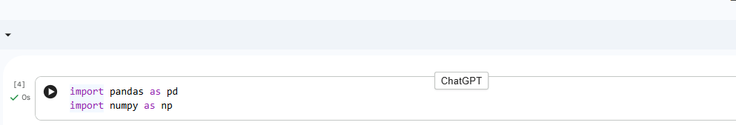

2. Load Dataset (CSV)
Write:
In this step, we load the Titanic dataset from a CSV file using pandas.
df = pd.read_csv("titanic.csv")
df.head()

3. Data ExplorationWrite: We explore the dataset using functions like head(), tail(), info(), describe(), and shape.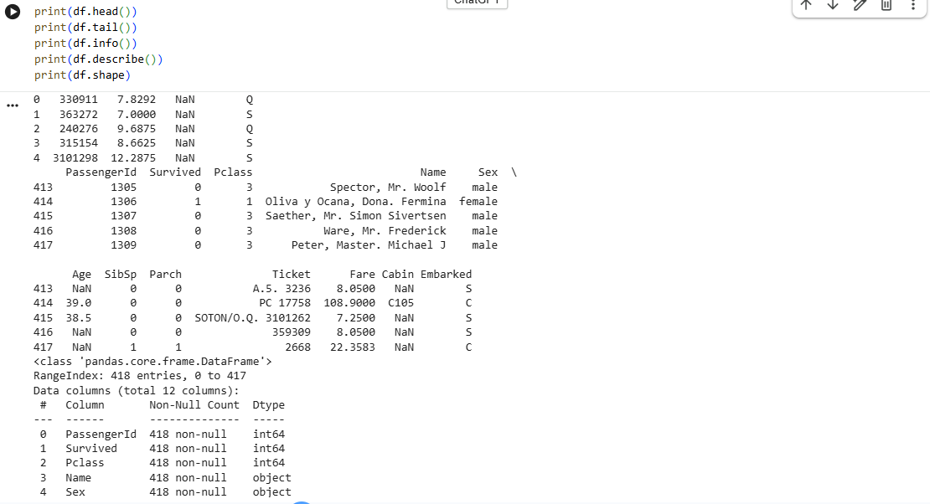

4. Column Selection
We select specific columns from the dataset.
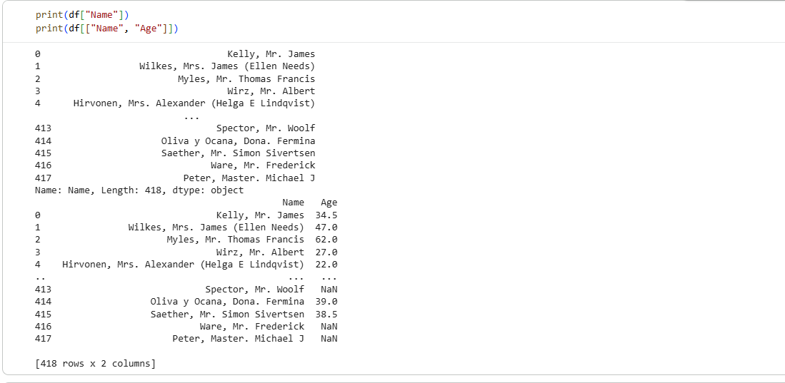

5. Filtering Data
We filter rows using conditions (Boolean indexing).
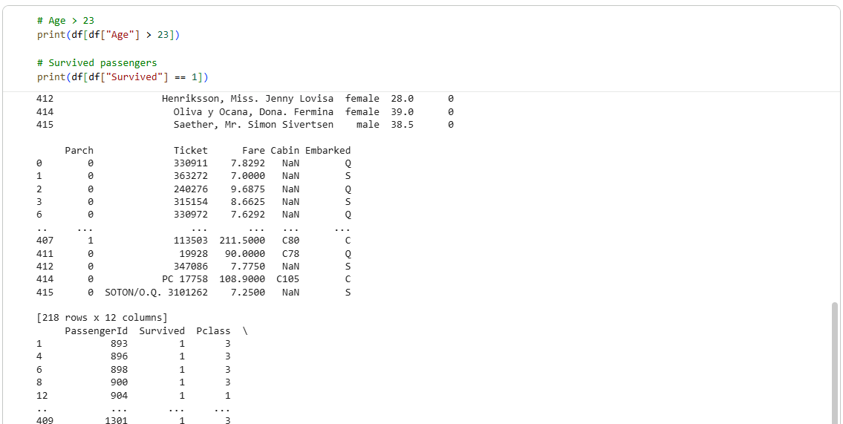

6. Sorting Data
We sort the dataset using single and multiple columns.
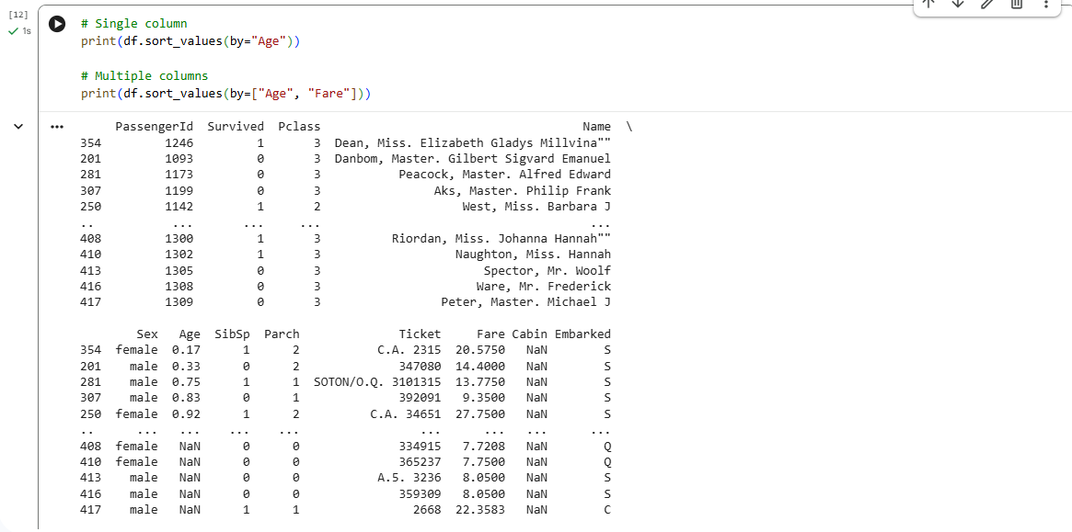

7. Handling Missing Data
We check and handle missing values using isnull(), dropna(), and fillna().

8. Column Operations
We add, remove, and rename columns in the dataset.

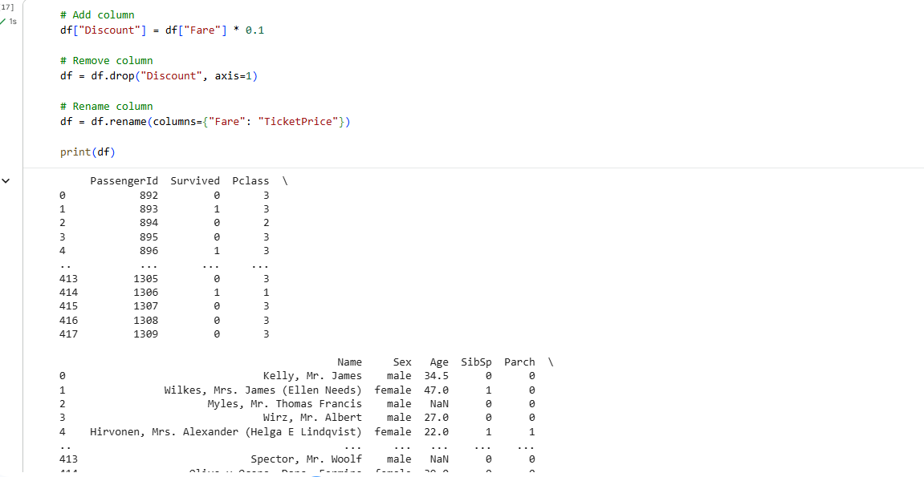

9. Conclusion
In this lab, we learned how to load, explore, and clean data using pandas.
This helps in real-world data analysis tasks.

